Technical Integration Documentation: SuccessFactors to Concur Worker Sync
1. Integration Overview
- Integration Flow Name: Mock_SF_to_Concur_Initial_Load
- Pattern: Scheduled Initial Load & Delta Synchronization
- Objective: To automatically pull employee profile data from SAP SuccessFactors, transform the payload structure and data types, and provision the users into SAP Concur for expense management.
- Source System: SAP SuccessFactors (Simulated via Postman Mock Server)
- Target System: SAP Concur (Simulated via Webhook.site)
- Trigger: Scheduled Timer
2. Architecture & Pipeline Steps
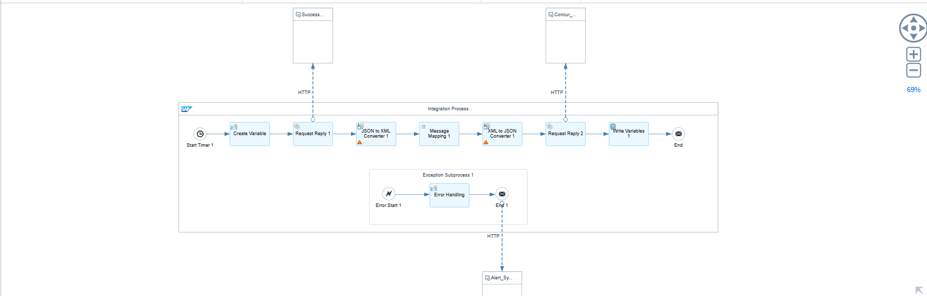
The integration follows a sequential routing and transformation pattern:
- Start Timer: Initiates the integration on a predefined schedule.
- Delta Sync Retrieval (Content Modifier): Reads the LastRunDate global variable from the SAP CPI tenant database to establish the time bounds for the data pull.
- Source Data Fetch (Request-Reply): Connects to the SuccessFactors OData API via HTTP GET.
- Format Conversion: Uses a JSON to XML Converter to parse the incoming SuccessFactors payload for mapping.
- Message Mapping (Map_SF_to_Concur): Executes structural mapping and logical transformations.
- Format Reversion: Uses an XML to JSON Converter to prepare the final payload for the Concur REST API.
- Target Delivery (Request-Reply): Pushes the JSON payload to SAP Concur via HTTP POST.
- Delta Sync Update (Write Variables): Stamps the current server time into the LastRunDate global variable for the next execution.
3. Data Transformation & Mapping Rules
A graphical message mapping (Map_SF_to_Concur) is utilized to translate fields between the source and target structures.
Key Transformation Rule:
- Field: status (SuccessFactors) $\rightarrow$ active (Concur)
- Logic: The source system provides the status as a single character (e.g., 't' or 'True'), but the target system requires a strict string boolean ('true' or 'false').
- Implementation: An equalsBoolean function checks if the input matches 't'/'True'. The result is routed through an if condition to output the exact string "true" or "false".
4. Fault Tolerance & Exception Handling
To prevent silent failures, the iFlow implements an Exception Subprocess.
- Trigger: Catches any runtime failure (e.g., HTTP 404, connection timeouts, or mapping exceptions).
- Action: A Content Modifier dynamically intercepts the exact system error using the Apache Camel expression ${exception.message}.
- Alerting: Generates a structured JSON alert containing the timestamp, iFlow name, and exact error message to be routed to IT Support/Monitoring systems.
5. Global Variables & Persistence (Delta Logic)
The pipeline leverages SAP CPI's Data Store Operations to remember its last execution time and prevent redundant data processing.
- Variable Name: LastRunDate
- Scope: Global
- Update Expression: ${date:now:yyyy-MM-dd'T'HH:mm:ss.SSS'Z'} (Captures exact runtime timestamp in ISO 8601 format)
6. Externalized Parameters
To ensure CI/CD portability between Dev, QA, and Production environments without modifying the code, the following parameters have been externalized:
- SF_Mock_URL: The endpoint URL for the SuccessFactors connection.

